# Module 1

**Tensors and Datasets**

**Tensors 1D & 2D**

## 📌 Overview of Tensors

Tensors are the foundational data structures used to construct and operate neural networks in PyTorch.

A neural network is fundamentally a mathematical function that accepts one or multiple inputs, processes them, and returns one or more outputs.

In PyTorch, this processing is performed using **tensor operations**, which are generalized versions of familiar mathematical operations like addition and multiplication.

### 🔹 Tensors as Building Blocks

PyTorch tensors serve as the unified representation for **inputs**, **outputs**, and **parameters** within a neural network. These tensors can represent vectors, matrices, or higher-dimensional data structures, depending on the application.

Tensor operations in PyTorch form the computational backbone of how data is manipulated and learned from in neural networks.

PyTorch tensors are a generalized form of **numbers and dimensional arrays** in Python.

* 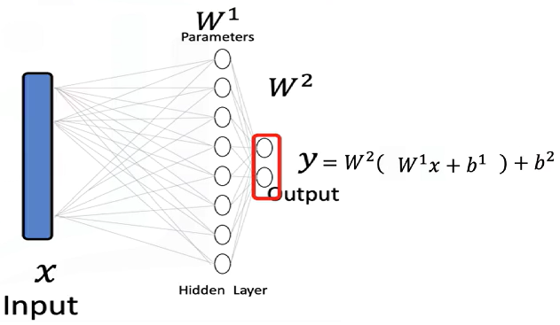The **input x** to a neural network is a tensor.
* The **output y** is also a tensor.
* The **parameters** of the model are tensors as well.
* Tensor operations allow the neural network to **transform inputs** into outputs during training and inference.

Neural networks use these tensor operations to apply **mathematical transformations**, often in the form of **vector and matrix operations**. These operations simulate the way real-world data is processed and are used throughout the course as the standard method for feeding data into neural models.

### 🔹 Examples of Tensors in Neural Networks

**Databases** can be treated as a series of tensors, where each row represents an input tensor (x) in a neural network.

A tensor is simply just a vector or a rectangular array consisting of numbers.

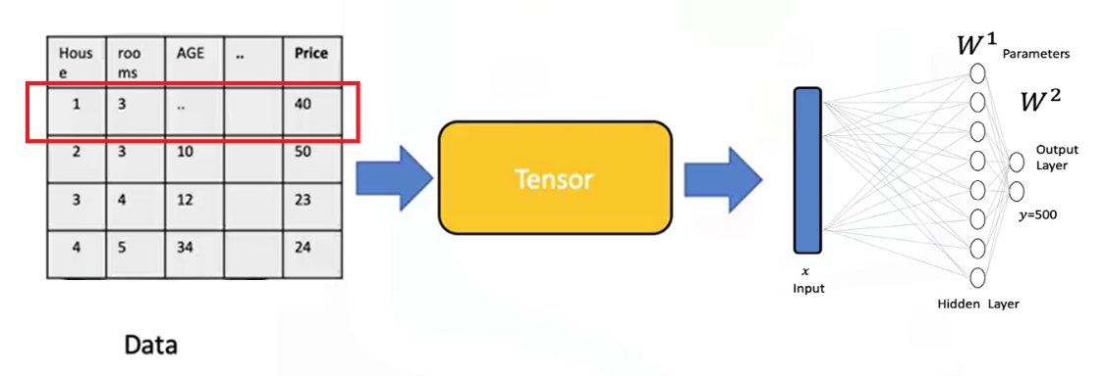

**Images** can be converted into 2D or 3D PyTorch tensors and used as input for classification tasks.

* + Each tensor of the input is simply a matrix or rectangular array.
  + Images are typically stored as arrays.
  + Neural networks can receive these as tensors and perform classification based on the processed values.
  + For instance, an image can be transformed into a tensor and classified as the digit **zero**.

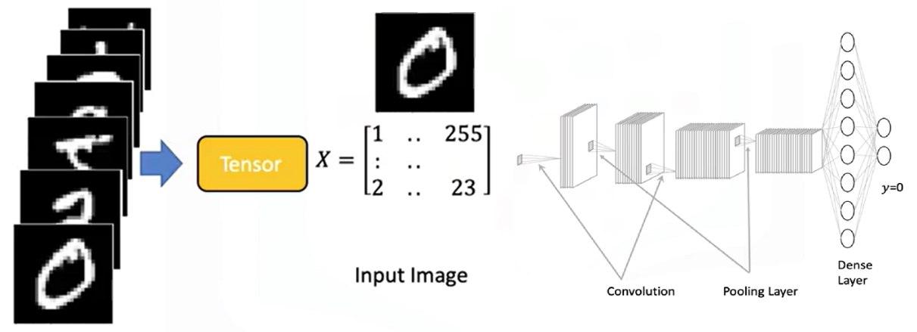

### 🔹 Tensor Conversion and Compatibility

PyTorch tensors can be easily **converted to NumPy arrays**, and NumPy arrays can also be converted into PyTorch tensors.

This bidirectional conversion enables seamless operation within the **Python ecosystem** and allows integration with many existing Python libraries.

PyTorch also supports **GPU acceleration**, which is crucial for training large neural networks efficiently.

### 🔹 Parameters and Derivatives in PyTorch

**Parameters** in neural networks are specialized tensors that allow for the calculation of **gradients and derivatives**.

These gradients are essential for learning during training.

To enable gradient tracking, PyTorch tensors must be created with **requires_grad=True**.

This setting allows PyTorch to automatically compute derivatives during backpropagation.

### 🔹 Dataset Class in PyTorch

PyTorch provides a **Dataset class** that simplifies working with large datasets.

Using this class enables efficient data handling, transformation, and loading.

It is especially useful when building neural networks that require batch processing or data augmentation.

### ✅ Takeaways

✅ PyTorch tensors are the core data structures used in building and training neural networks.

✅ Inputs, outputs, and model parameters are all represented as tensors.

✅ Tensor operations in PyTorch generalize familiar mathematical operations and are essential for transforming input data.

✅ Databases and images can be represented as tensors and processed within neural networks.

✅ PyTorch integrates seamlessly with NumPy and supports GPU acceleration for scalable training.

✅ Setting requires_grad=True enables tensors to compute gradients, allowing for neural network training.

✅ The Dataset class simplifies data management and is essential for working with large-scale training data.

## 📌 Tensors 1D

### 🔹 Understanding 1D Tensors

* A **0D tensor** represents a single number.
* A **1D tensor** is an array of numbers and can represent:
* A row in a dataset
* A vector
* A time series
* A tensor contains elements of a **single data type**, there is a variety of different tensor types depending the data type of the elements in the tensor, such as:
* float or double tensors (for real numbers)
* byte tensors (for 8-bit images and unsigned integers)

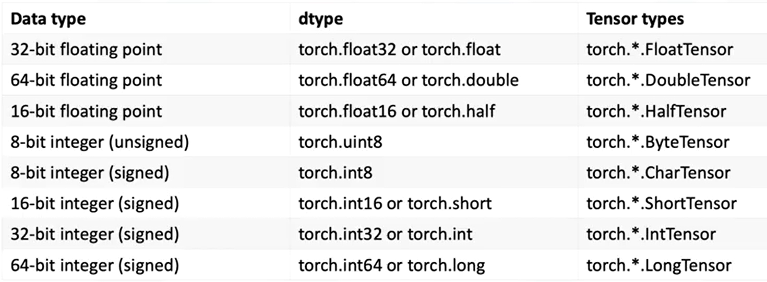

### 🔹 1D Tensor Operations

🔸 **Creating a tensor:**

* + Use **torch.tensor()** to convert the list into a tensor.
  + Data can be accessed via index.

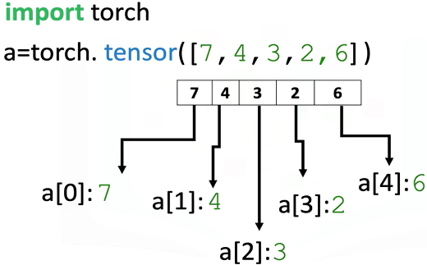

🔸 **Tensor Type and Data Type:**

* + Use the **.dtype** attribute to identify the data type stored in a tensor.
  + Use **.type()** to identify the tensor type.

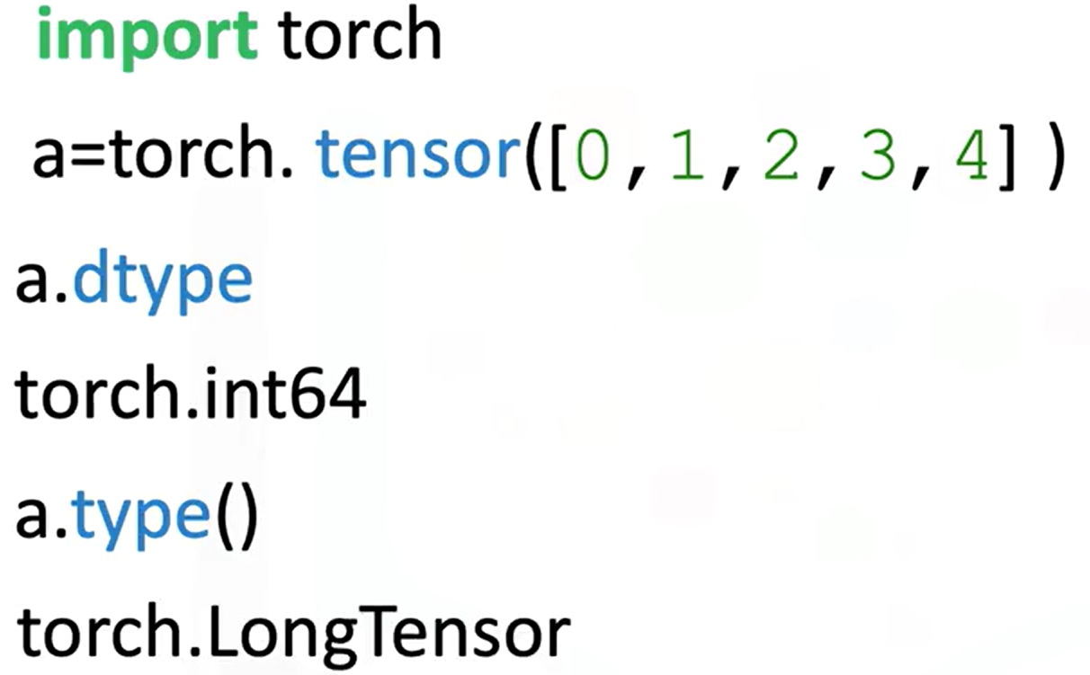

* + Explicitly set the data type using the **dtype** parameter.



* + Using classes like **torch.FloatTensor**.

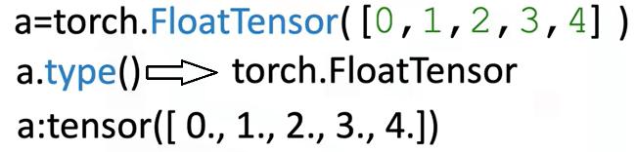

* + Use **.type(torch.FloatTensor)** to convert to a float tensor.

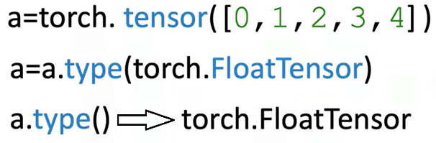

🔸 **Tensor Size and Shape:**

* + Use **.size()** to find the number of elements.
  + Use **.ndimension()** to find the number of dimensions (tensor rank).

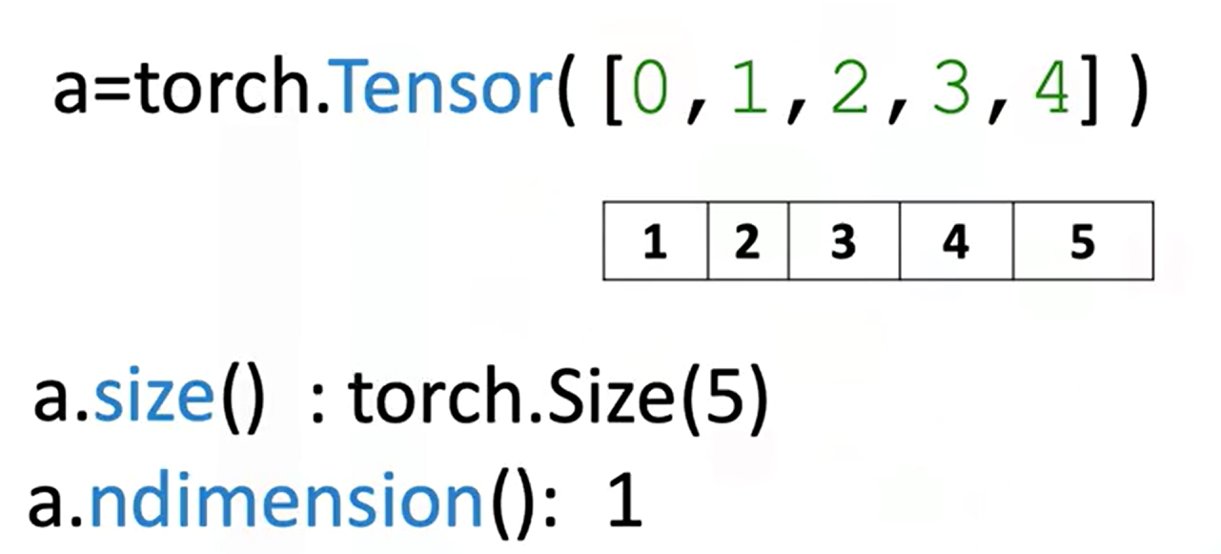

* + 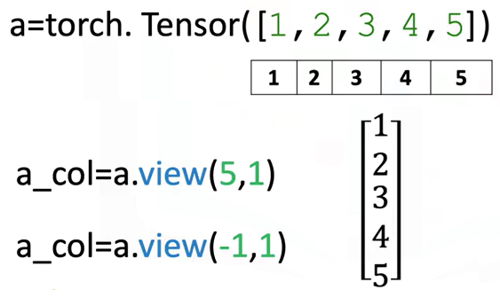Convert a 1D tensor to 2D using **.view(number_rows, number_cols)**:
* **view(5, 1)** turns a 1D tensor with 5 elements into a 2D column tensor.
* Use **view(-1,1)** to let PyTorch infer dimensions.

🔸 **Tensor Conversion with NumPy and Pandas**

* + Convert a NumPy array to a tensor with **torch.from_numpy()**
  + Convert a tensor to a NumPy array using **.numpy()**

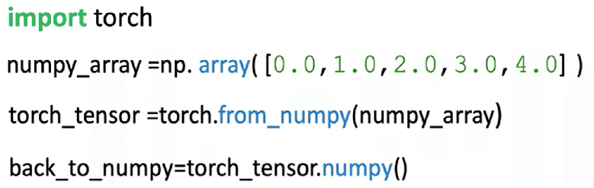

**⚠️ Memory sharing:**

Modifying the original NumPy array affects the PyTorch tensor and vice versa.

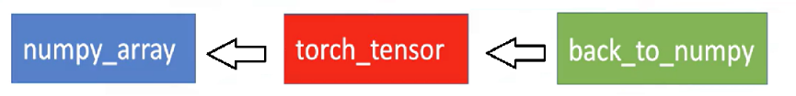

* + Convert Pandas series to tensor:
* Use **.values** to get the NumPy array
* Then apply **torch.from_numpy()**

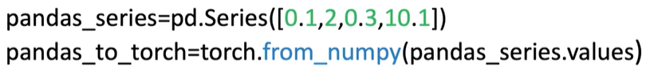

* + Convert tensor to list:
* Use **.tolist()** to get a Python list

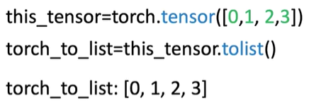

* + Convert tensor element to number:
* Use **.item()** to extract a Python number from a single-element tensor

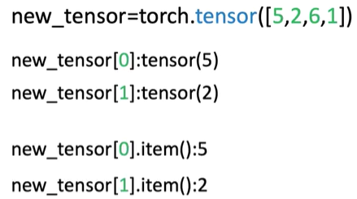

🔸 **Indexing and Slicing:**

* + Access tensor elements with index (e.g., a[0])
  + Assign new values to specific elements (e.g., a[0] = 100)

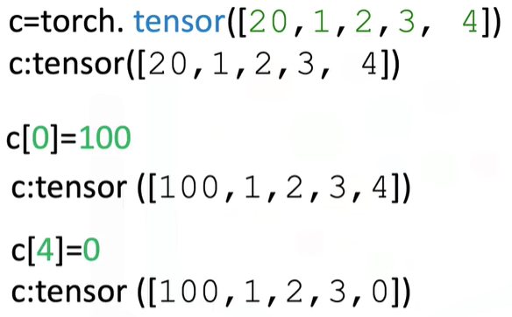

* + Slice a tensor like a list: a[1:3]
  + Assign values to slices (e.g., a[1:3] = [1, 2])

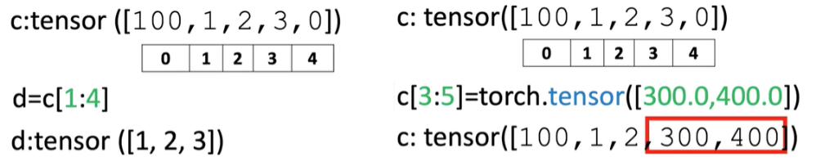

🔸 **Basic Tensor Operations:**

These operations are essential for building neural networks and understanding how tensors interact mathematically:

* + Vector Addition:

Combine two tensors element-wise.

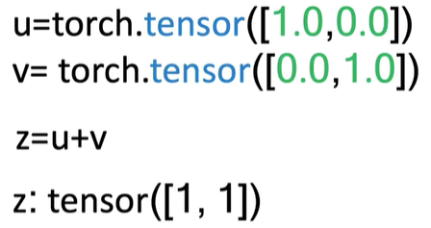

* + Scalar Multiplication:

Multiply each element of a tensor by a scalar.

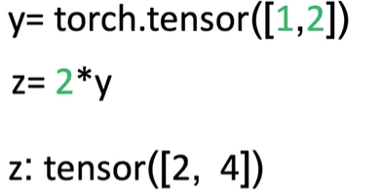

* + Hadamard Product (Element-wise Multiplication)

Multiply corresponding elements of two tensors.

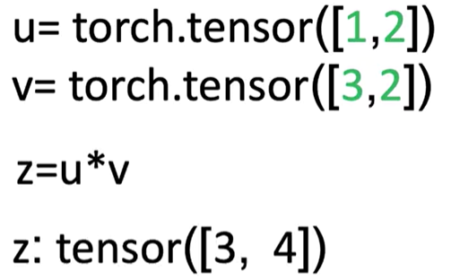

* + Dot Product

Produces a single number that measures similarity between two vectors.

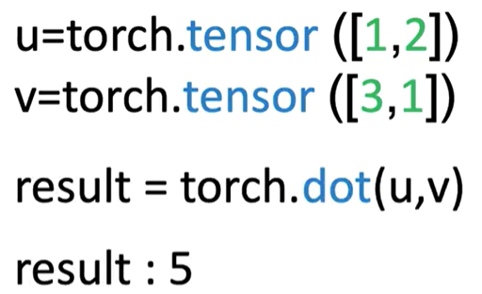

* + Broadcasting

Adding a scalar to a tensor adds it to each element.

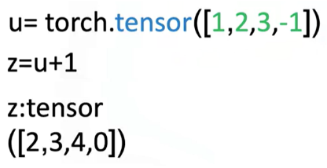

🔸 **Universal Functions:**

Apply operations across all elements:

* + **a.mean()**:

Computes the average

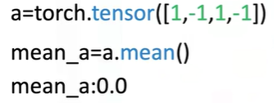

* + **b.max()**:

Returns the maximum value

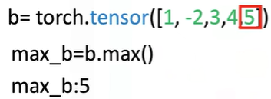

* + Use functions like **torch.sin()** to apply to every element of a tensor

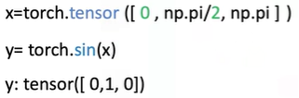

* + Use **torch.linspace(start, end, steps)** to generate evenly spaced values.

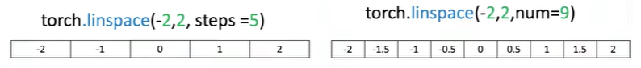

🔸 **Plotting with Tensors:**

* + Use **matplotlib.pyplot**
  + Use **%matplotlib inline** for inline notebook rendering
  + Convert tensors to NumPy before plotting: **.numpy()**

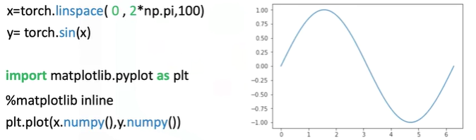

### ✅ Takeaways

✅ **1D tensors** are core structures for data representation in PyTorch.

✅ Tensors can be **easily created, indexed, sliced, and reshaped** using intuitive syntax.

✅ PyTorch supports **type casting**, **NumPy/Pandas conversion**, and **interoperability** with Python tools.

✅ Tensor operations include **vector arithmetic**, **dot product**, **broadcasting**, and **universal functions** like mean and max.

✅ PyTorch allows mathematical functions (like sine) to be applied element-wise, enabling visualization and numerical analysis.

✅ Tools like linespace and matplotlib can be combined with PyTorch tensors for **function plotting and visualization**.

## 📌 Two-Dimensional Tensors

### 🔹 Understanding 2D Tensors

A 2D tensor is a container that holds numerical values of the same type and is typically visualized as a matrix.

In real-world applications, 2D tensors can represent:

* **Tabular data**, where each row is a sample (e.g., a house), and each column is a feature (e.g., number of rooms, age, price).

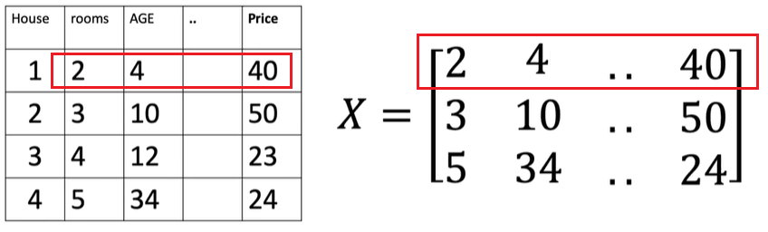

* **Grayscale images**, where pixel intensities range from 0 (black) to 255 (white), forming a 2D grid.

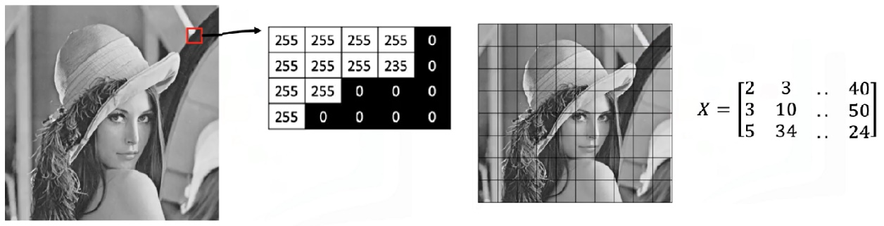

Tensors can be extended beyond two dimensions:

* **3D tensors** are used to represent color images, where each channel (red, green, blue) has its own 2D matrix of intensity values.

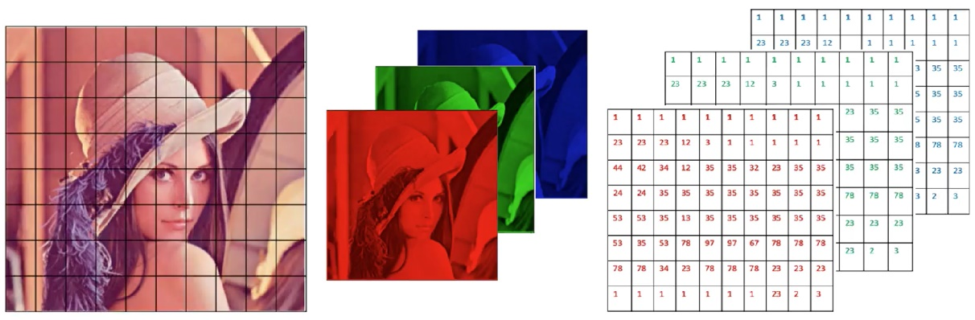

* Higher-dimensional tensors (e.g., 4D) are also used in deep learning.

### 🔹 Creating 2D Tensors

A 2D tensor can be created from a nested list, where each inner list represents a row.

The structure is interpreted as a rectangular matrix:

* The outer dimension represents rows.
* The inner dimension represents columns (eg: each element on a list, in this case since we have three elements in each list we have three columns).

Important tensor attributes:

* 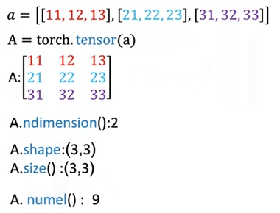**Number of dimensions (rank)** can be queried to confirm the tensor structure.
* **Shape** returns the count of rows and columns.
* **Size** can be used interchangeably to obtain shape.
* **Number of elements** can be calculated by multiplying rows and columns or using a built-in method.

### 🔹 Indexing and Slicing

Indexing allows extraction of individual values, partial rows, or partial columns from the tensor for further computation or inspection.

It’s performed using two indices:

* The first index corresponds to the **row**.
* The second index corresponds to the **column**.

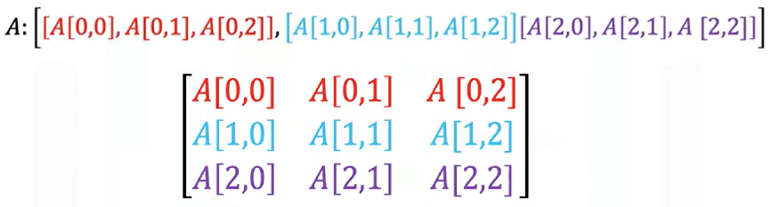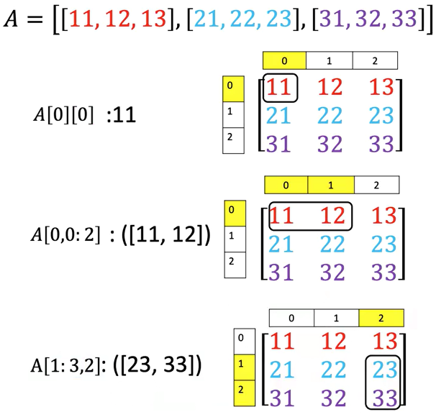

### 🔹 Basic Operations on 2D Tensors

🔸 **Addition:**

* + 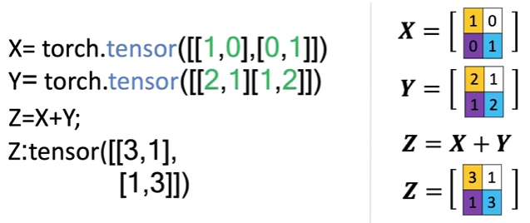Two tensors of the same shape can be added together.
  + This performs element-wise addition, similar to matrix addition in linear algebra.
  + 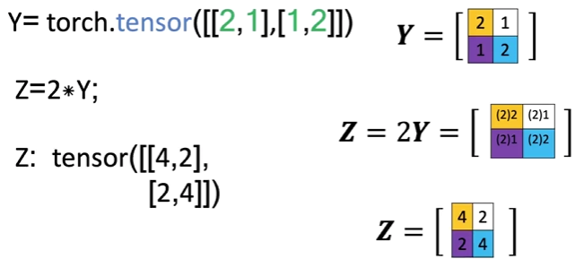Each element in the result is the sum of the corresponding elements in the input tensors.

**🔸 Scalar Multiplication:**

* + Multiplying a 2D tensor by a scalar scales each individual element.
  + The resulting tensor is the same shape, but each value is multiplied by the scalar.

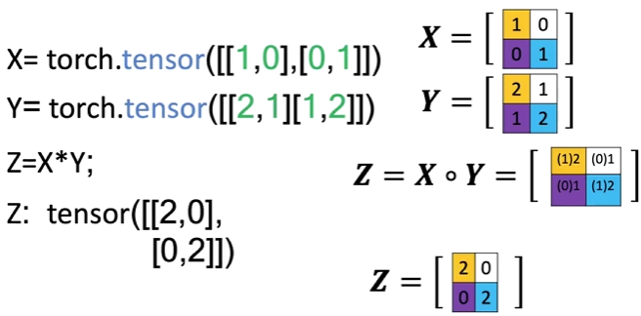🔸 **Hadamard Product (Element-wise Multiplication):**

* + Multiplies corresponding elements of two tensors of the same shape.
  + Produces a new tensor where each value is the product of the matching elements from the inputs.

🔸 **Matrix Multiplication:**

* + 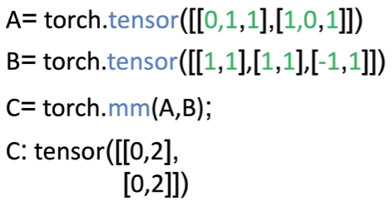Follows standard linear algebra rules:

The number of columns in matrix A must match the number of rows in matrix B.

* + For each element in the resulting matrix:

Compute the dot product between a row from matrix A and a column from matrix B.

* + The result is a new matrix with a shape defined by the row count of matrix A and the column count of matrix B.
  + Matrix multiplication yields a meaningful transformation of input features, often used in neural network layers.

### ✅ Takeaways

✅ 2D tensors are commonly used to represent both **structured data** (like spreadsheets or tables) and **images** (grayscale and multi-channel).

✅ Tensors can be **indexed, sliced, and reshaped** to access and manipulate specific data points or submatrices.

✅ Arithmetic operations like **addition**, **scaling**, **element-wise multiplication**, and **matrix multiplication** are supported natively and follow familiar linear algebra principles.

✅ 2D tensors provide the foundation for **layered neural network computations**, especially in the early stages of data processing and feature transformation.

✅ The structure and operations on tensors mirror real-world mathematical concepts, making them an intuitive and powerful abstraction for machine learning.